Kevin Gillis
History 397VW

Historical Signage:
Blue Hills CCC Camp

The Blue Hills Reservation is a state park in eastern Massachusetts comprised of over 6,000 acres of land in the municipalities of Randolph, Canton, Milton, Dedham, Braintree, and Quincy. The park is a popular spot for hikers and outdoor enthusiasts, as well as families who visit the trailside museum where they can view examples of the local wildlife. As the name suggests, the park includes several rocky hills. The tallest of these, known as Great Blue Hill, provides visitors with panoramic views of Boston harbor and the city’s iconic skyline. In order to access these views, one must first ascend the steps of a stone tower, called Elliot’s Tower. Thousands of annual visitors enjoy the sights from the tower, yet, unbeknownst to the majority of them, myself included, this privilege would not have been possible without the hard work of the men of the Civilian Conservation Corps who once called the Blue Hills home.
From 1933 to 1937, hundreds of men found employment in the midst of the Great Depression at Camp Blue Hills in Milton, including my own grandfather, James Gillis, who was born on January 9, 1919, and died August 3, 1986. Contemporary visitors to the park still enjoy the fruits of their labor, which include many of the park’s trails. These trails vary in length and difficulty, from the steep and challenging “Skyline” trail, to more flat and winding nature trails. Today, all that remains of this legacy is a simple sheet-metal sign along one of the trails, stating that somewhere around the sign, a camp once stood. I believe that this inconspicuous sign does not sufficiently honor the men of the C.C.C., nor does it accomplish the goal of creating a link between the past and the present. In order to establish this bond, and instill a sense of awareness and appreciation in contemporary visitors: something much more visible and interactive needs to be created.
The majority of the park’s visitors are completely unaware that a C.C.C. camp once operated within it, and the first step that should be taken is to create some awareness. Visitors can acquire trail maps, yet the site of the former camp is nowhere to be found on these maps. If the camp was marked on the maps, then visitors would view it as a destination that deserved further exploration, rather than a mere curiosity along one of the many trails. However, simply placing the camp on a map will not suffice.
If money were no object, then I would propose that the state tear down the meager sign that currently marks the camp, and instead construct a replica of a Civilian Conservation Corps building, or perhaps one of the entire camp itself. This building, or set of buildings, could then act as a trailside C.C.C. museum, providing visitors with a chance to figuratively step inside the past and glimpse what life was like for the men of Camp Blue Hills. State agencies could reach out to relatives of C.C.C. members for mementos such as photographs, uniforms, or other personal objects that they may be willing to donate to the museum, in order to ensure that their ancestors’ legacies live on. The museum would be staffed by one or two individuals who could provide visitors with additional information, assist those who may be inquiring about relatives who worked in the camp, like myself, and of course, collect donations.
A reconstructed camp that doubles as a museum would be the central focus of the project, but I would also propose that more detailed signs and exhibits be constructed throughout the park complex. These signs would be far more inviting than the current sign marking the camp, which looks like something one would pass on a highway without even noticing. The proposed signs would detail points of interest for the C.C.C., such as the Eliot Tower, and would utilize pictures to draw visitors’ attention. In addition, the signage could educate visitors on the Native American inhabitants who once called the area home, and from whom the name Massachusetts is derived.
To conclude, it is evident that the current signage denoting the location of Camp Blue Hills is insufficient, and must be reworked to provide visitors with a more enlightening experience. The creation of a trailside C.C.C. museum would draw more visitors to the park, and even those with no previous interest or knowledge of the camp would be intrigued by the and enticed to learn more about the legacy of the program. In addition, the museum and accompanying signage could provide C.C.C. member’s relatives with a tangible link to their family history, not to mention the revenue that could be generated for the state through tours and other operations. Most importantly, the project would provide visitors with a greater understanding of and appreciation for the oft-forgotten legacies of the Great Depression.

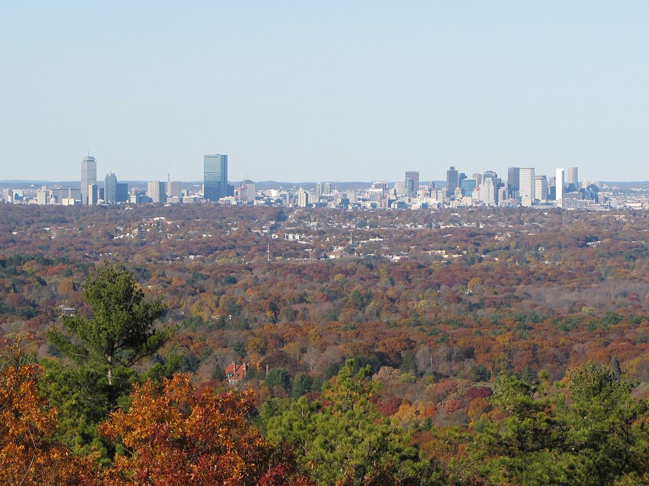
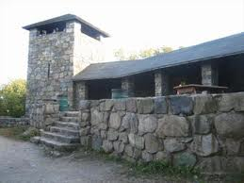
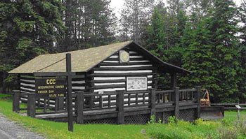
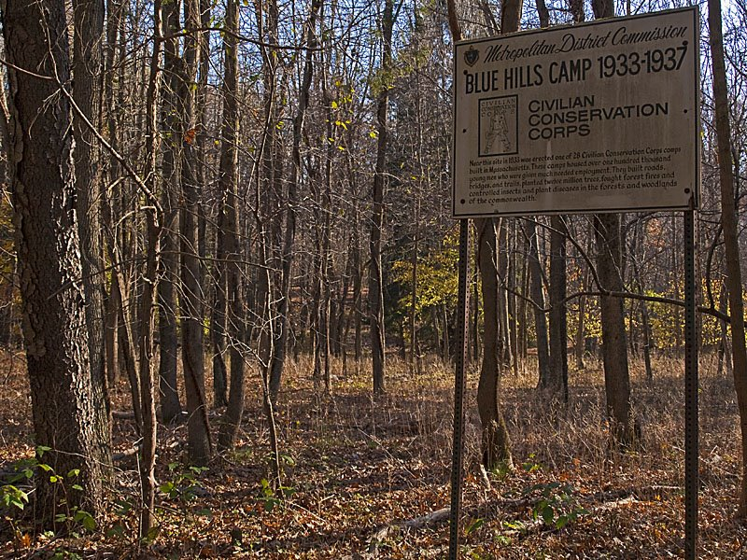
Current signage at Camp Blue Hills
Example of C.C.C. Museum in PA
Eliot Tower, Built by the C.C.C.
View of Boston Skyline from the Eliot Tower

